**Motile strain of fluorescent *Escherichia coli* move following increasing concentration of nutrients**

*Lucile Szpiro, Régine Roncucci, Cécile Crapart, Floriane Coulmance--Gayrard*

**Abstract**

Microbiology is a specific field of biology that study microorganisms such as *E.coli*. Owing to its ease of handling for low cost, this bacteria has intensively been studied by biologists, geneticists and our knowledge considering this bacteria had largely increased within the years. Our main goal here was to study its motility and link it to biology and chemistry. We wanted to know if Red Fluorescent Protein (RFP) *E.coli* could sense an increase of nutrient concentration and move to follow it. Does RFP expression have an influence on *E.coli’*s response to a nutrient gradient ? Here we show that RFP *E. coli* effectively advanced on plates to reach region more concentrated in nutrients. This findings suggest that they use their flagella to move toward nutrients in order to develop colonies in more conducive environment. So here we have a large discovery in *E.coli*’s behaviour. It shows that their main goal as individuals but more largely as a group is to grow and maintain their survival. As this is now proved, what could be interesting is to see if there is a competition between different strains, species of *E.coli* in their quest for food.

***Escherichia coli* can move to reach nutrients**

RFP *Escherichia coli*, a simple model organism to study motility

*Escherichia coli* is bacteria, a one cell organism. This bacteria is largely used in microbiology as it is the simplest organism to study complex mechanisms. Its cell is composed of a membrane, a cytoplasm, and no distinct nucleus. A single flagellum allow them to undergo directed movement toward food supply for example, through changes in its rotary behavior1. Bacterial nutrients are sugar, alcohol or amino acids that they need to develop and make some colonies**2**. Depending on the nutrients available, their growth can be affected.

In this study we use an RFP (Red Fluorescent Protein**3**) strain among the multiple different strains of *E. coli* to easily distinguish them using a fluorescent lamp. RFP’s basic function is to emit light (in the red visible part of light spectrum) in response to a specific light wavelength (558 nm). Depending on where the RFP is expressed within the cell, it can cost different energy.

*E. coli* growth depends on the nutrients in the media

*E. coli*  is a bacteria living in the lower intestine of warm-blooded body such as humans. It estimal growth is at 37°C.

*E.coli* divide each 20 minutes in a rich medium such as LB, which contains synthesized nutrients beside strictly necessary ones4 unlike in minimal media such as M9**5**.

A previous study determined a growth model for bacteria growing in heterogeneous conditions**5**. As those bacteria can move thanks to their flagella and need nutrients to grow, here we wanted to know how they would respond to a nutrient gradient. Our hypothesis was that bacteria would move toward region more concentrated in nutrients following the gradient and develop more and larger colonies there.

**Original methods were used to create nutrient gradients**

RFP *E.coli* strain grew in liquid LB, rich medium

First we prepare a culture of RFP strain by inoculated some bacteria in a 10 mL media for one night at 37°C incubator. From this overnight culture, we make some serial dilution in LB until 10-6 factor to have 2 falcons of 10 mL of well feed RFP *E.coli* to put for one night at 37°Celsius incubator again. Our 2 falcons correspond to biological replicates.

Water concentrated at 0.3% of agar used for negative controls

Our negative control consist in testing *E.coli* culture on plate without any nutrient gradient. This aims to determine if they are already moving in an homogeneous media with the minimum possible nutrient and in case, in which direction.

For that, we created plates with only water and 0.3% agar using results from a study of 2011 on bacterial swarming6. Agar is a mixture of polysaccharide agarose (linear molecule) and agaropectin (smaller molecules). Basically, it provides few sugar for bacteria to survive and grow normally. We did 5 technical replicates.

This media was created in four steps.

1. Filter 1 L of distilled water thanks to 5 filters and one 50 mL syringe. Fill two recipients of 500 mL with filtered water and add 1.5 g of agar in each (agar concentration: 0.3%)
2. Boil recipients for 5 minutes using a microwave (the stopper need to be a little bit open so that is can not explode).
3. Shake it for 2 minutes in order to completely dissolve agar in water.
4. Pipette 25 mL of this boiled solution to fill plates. It should look like jelly after 10 to 15 of drying.

Nutrient gradient physically created by tilling plates

To create the nutrient gradient, we used a physical method7. We filled half plates with 12.5 mL of LB medium and tilted it ( ± 1/2 cm) in order to have an increasing volume of LB along the plate. After 10 to 15 minutes of drying, LB solidified; the slope thus created determine the nutrient gradient. We then completed plates with 12.5mL of water at 0.3% agar.

Purify bacteria to remove them from rich medium before starting experiments

Purify *E.coli* is a technique used here to be sure they are not anymore in contact with any LB medium when experiments starts. Indeed, they could continue to grow on this medium without moving toward food on the plate. We centrifugate them and took out the supernatant to replace it by filtrated water three times (fig. 1).

Then we deposited a drop of 5 µL in each plate at the beginning of the nutrient gradient in the less concentrated region in nutrients.

We took pictures under fluorescent lamp (filter of 588 nm) after 15h, 23h, and 40h. Plates were not placed in an incubator.

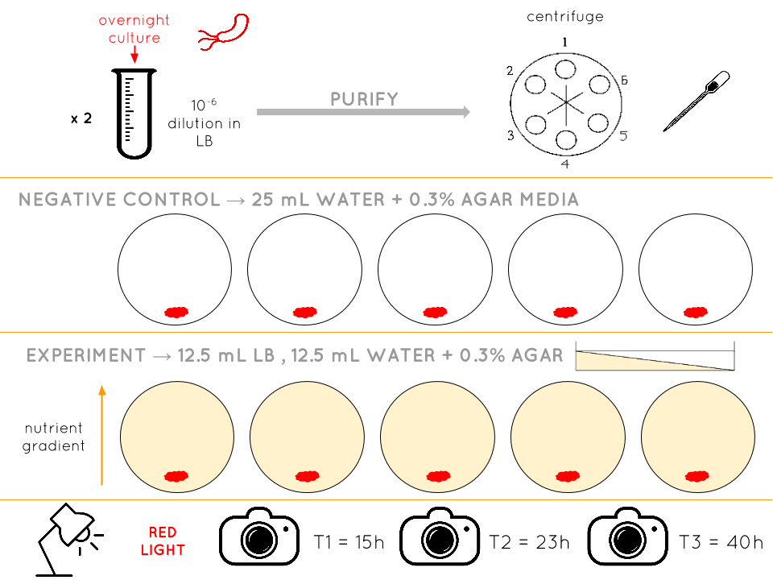

***Fig. 1****. Experimental set-up: RFP strain of E.coli were grown in a rich medium (liquid LB) for one night (two biological replicates). The culture were purified by centrifugation and rinsing before starting experiments. Bacteria were disposed on the region less concentrated in nutrients (5 technical replicates). Negative controls were practiced on plate with only water and agar and no nutrient gradient. Pictures were taken under red fluorescence lamp after 15h, 23h and 40h.*

**Plates were divided in areas and a new formula was implemented to analyse data**

Dividing plates in 5 areas to normalize picture analysis

To evaluate the bacterial response to the nutrient gradient, we divide plates in five distinct areas (1.8 cm each). Area 1 correspond to the region of the plate less concentrated in nutrients wheres area 5 is the higher concentrated side. The breakdown of plates allowed us to simplify the pictures analysis and normalize it. It indeed helped to easily determine if some bacteria effectively move toward the gradient to develop a colony in a more conducive environment. Thus, we considered two parameters indicating *E. coli* response to the nutrient gradient: the number of colonies and their size in each area.

First response indicator: Colonies’ number along the gradient at 3 times

We represented the average number of new colonies appeared in each area over time (fig. 2). The nutrient gradient is represented in the x-axis by the area number.

Our controls (see Supplementary materials, fig. 1) indicated that there were no developed colonies in any areas of plates without nutrient gradient over the entire experiment. Therefore the response observed in test is necessarily due to the nutrient gradient in the plate.

The number of colonies globally increase over time. After 15h, colonies are still mostly in areas 1 and 2. However, some colonies appear in areas 2, 3, 4 and even 5, more far away from the starting point of bacteria, after 23h. It suggest that some bacteria moved following the increasing nutrient concentration to start colonies. As most of the colonies developed in area 2, we assumed that bacteria stopped moving forward when the environment provided enough nutrient to grow. It seems to be confirmed by the measure after 40h: most of colonies are still developing in area 2 or 3. We can expect that after a longer time, the number of colonies found in areas 4 and 5 will increase and be higher than in preceding areas, where nutrients will have already been consumed.

*Fig. 2: Number of new colonies per area over time. Plates were divided in 5 areas of equal width. The average number of colonies in areas is considered as an indicator of bacterial response to nutrient gradient. The large number of colonies in area 2 suggest that bacteria stop moving forward when the environment already provide enough nutrients to grow.*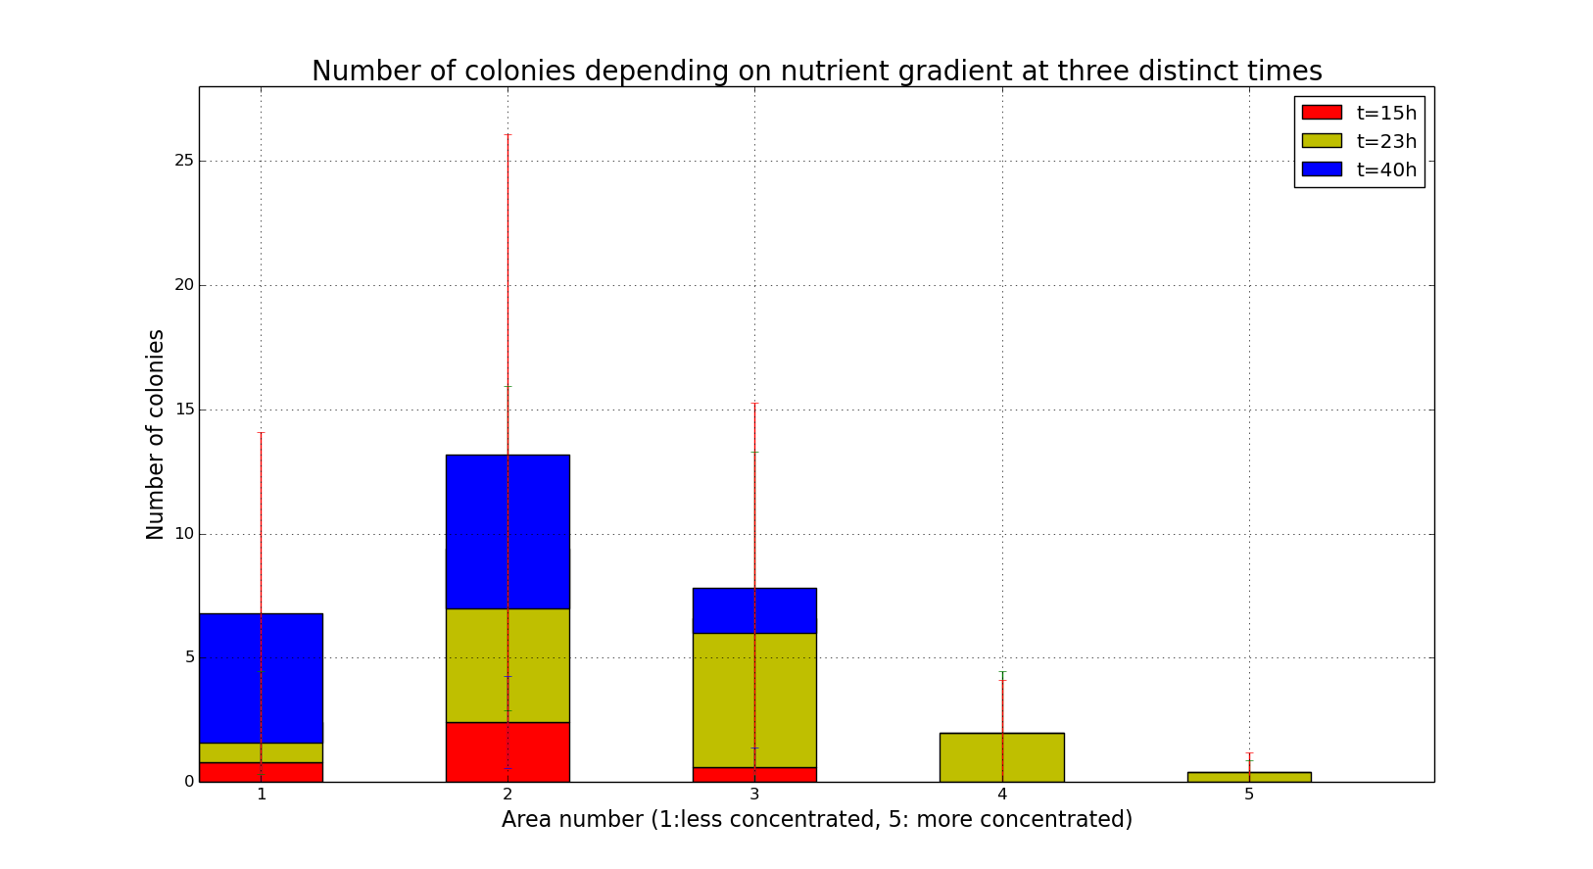

Second response indicator: Colonies’ size along the gradient at 3 times

To determine the size of our colonies we established a scale, the smallest one were normalised at 1 and the larger one at 16 (arbitrary units). The average size of colonies has also been plotted depending on the area where they were counted (fig. 3). Without nutrient gradient, colonies stayed very small all along the experiment (Supplementary materials, fig. 2). It shows that colonies were larger in area 2 after 15h than in other areas. It verify our previous hypothesis : bacteria has enough nutrients in area 2 to develop growing colonies. However, after 40h, the average size of colonies is higher in area 3 with more nutrients. So after a longer time (maybe 80h), the size of bacteria should be higher in area 5 than in preceding areas because bacterial growth will not be limited by nutrients quantity there.

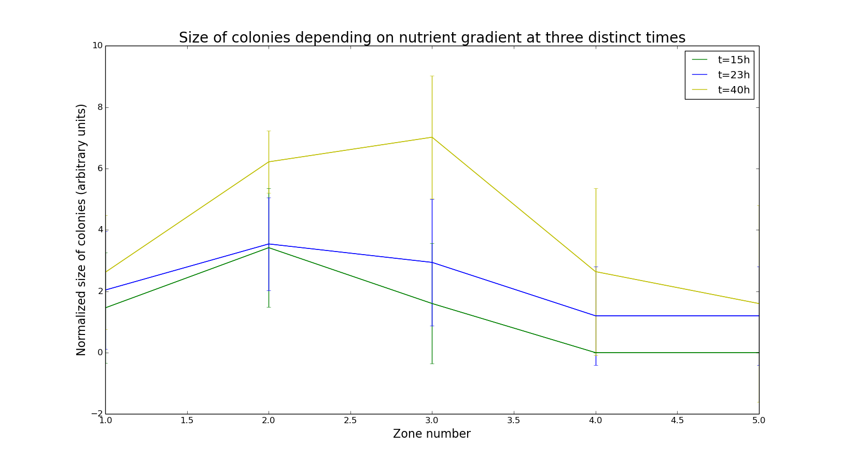

*Fig. 3: Size of colonies per area over time. Plates were divided in 5 areas of equal width. The average size of colonies in areas is considered as an indicator of bacterial response to nutrient gradient. The maximal size of bacteria is shifting toward areas more concentrated in nutrients.*

A new rating to analyse our data

We decided to gather the 3 parameters indicating a response to the gradient (advancement, number and size of colonies) in a response coefficient (χ). We summed the product of the mean number of colonies (0 to 27), size average (0 to 16) and squared area number (1 to 25) from the 5 areas. We squared area number in order to give it the same weight than to the other parameters.

$χ =Σ area{{}^{2}×number of colonies ×average size}^{}$

The graphical representation of this coefficient as a function of time (fig. 4) indicate a linear trend after 15h. It shows that bacterial response is more pronounced over time. Hence, this coefficient can be a useful tool to quantify bacterial response easily. After 15h we can observe a linear trend, but the large standard deviations do not allow to make clear conclusions about it. This can be explained by colonies stabilisation in region with enough nutrients as explained previously or by the death of some bacteria in areas with very few nutrients.

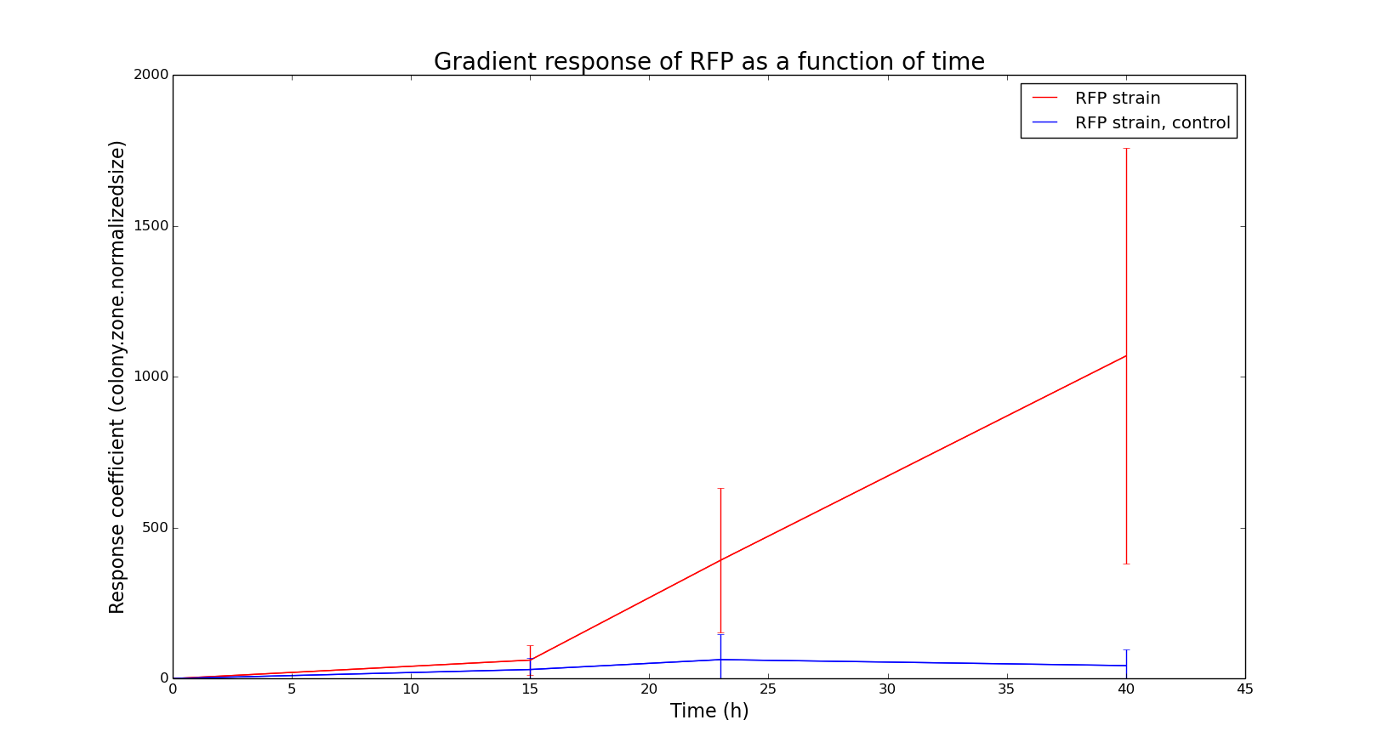

*Fig. 4: Response coefficient to nutrient gradient over time. This coefficient is calculated from three parameters indicators of bacterial response: position in the plate, mean number and mean size of colonies in the area. It suggest that bacterial response is increasingly pronounced over time.*

**RFP E. coli respond to a gradient of nutriments**

According to all those parameters, we can conclude that RFP *E. coli* effectively respond to the nutrient gradient. The number of colonies in areas closer to the more concentrated region should increase over time, when nutrients in preceding areas will have been consumed. The maximal size of colonies should increase and shift toward areas with no nutrients constraints after long time periods. The considered parameters can be used to determine an increasing response coefficient, consistent with observations.

**Deposit bacteria in the center of plates to extend conclusions**

As bacteria were deposited in an extremity of the plate, our analysis is limited by the fact that bacteria could not move against the gradient. Therefore, bacteria should be placed in the middle of the plate so that we would be able to determine if they move toward the more concentrated region by sensing it. For negative control, plates without gradient should have been half filled with LB and half water at 0.3% agar without gradient to avoid the eventual death of bacteria.

**Interactions between different *E.coli* strains can affect their motility**

Although we studied the influence of a nutrient gradient on satiated bacteria’s motility, our first aim was to compare the response of starving and satiated *E.coli* to a nutrient gradient. A following study would consist in performing the same protocol as in this study with *E.coli* grew in a minimal media (M9). With the same analysis as described before, we would be able to compare results and conclude about the potential difference in bacterial response to gradient depending on their nutritional culture conditions.

Bacteria of the same speci have their own signal that no other species can detect, although some signals can also be common to different species and even for all species. Knowing that *E.coli* have specific chemical signals**8** to recognize each other, a continuation to our work would be to study how bacterial interactions affect their response to a nutrient gradient. For those experiments, we would, in addition to starving and satiated RFP *E.coli*, grow starving and satiated GFP *E.coli*. In that case we would be able to study the impact of interactions between bacteria of the same strain but also from different strains9,10 in each starving or satiated conditions, by putting them on the same plates.

**Special acknowledgement to**

Daniel Kearns that was pleased to answer our question and gave us advices regarding our experiment.

Tamara Milosevic and Aïmen El Assimi for staying in the lab while we had some troubles with our devices.

Paul-Henry Baranek for helping us think and coordinate team work.

**Bibliography**

1. Ks.uiuc.edu, (2016). Bacterial Flagellum. [online] Available at: http://www.ks.uiuc.edu/Research/flagellum/ [Accessed 22 Feb. 2016].
2. Textbookofbacteriology.net, (2016). Nutrition and Growth of Bacteria. [online] Available at: http://textbookofbacteriology.net/nutgro.html [Accessed 22 Feb. 2016].
3. Thermofisher.com, (2016). Red Fluorescent Protein (RFP) | Thermo Fisher Scientific. [online] Available at: https://www.thermofisher.com/fr/fr/home/life-science/cell-analysis/fluorophores/red-fluorescent-protein.html [Accessed 22 Feb. 2016].
4. Microbelibrary.org, (2016). Luria Broth (LB) and Luria Agar (LA) Media and Their Uses Protocol. [online] Available at: http://www.microbelibrary.org/component/resource/laboratory-test/3031-luria-broth-lb-and-luria-agar-la-media-and-their-uses-protocol [Accessed 22 Feb. 2016].
5. Koster, D., Mayo, A., Bren, A. and Alon, U. (2012). Surface Growth of a Motile Bacterial Population Resembles Growth in a Chemostat. Journal of Molecular Biology, 424(3-4), pp.180-191.
6. Kearns, D. (2010). A field guide to bacterial swarming motility. Nature Reviews Microbiology, 8(9), pp.634-644.
7. Bisen, P. (2014). Laboratory protocols in applied life sciences. Boca Raton: CRC Press.
8. Fuqua, C. and Greenberg, E. (1998). Cell-to-cell communication in Escherichia coli and Salmonella typhimurium: They may be talking, but who’s listening?. Proceedings of the National Academy of Sciences, [online] 95(12), pp.6571-6572. Available at: http://www.pnas.org/content/95/12/6571.full [Accessed 22 Feb. 2016].
9. Hibbing, M., Fuqua, C., Parsek, M. and Peterson, S. (2009). Bacterial competition: surviving and thriving in the microbial jungle. Nature Reviews Microbiology, 8(1), pp.15-25.
10. RC, M. (2016). Role of nutrient limitation in the competition between Pseudomonas fluorescens and Escherichia coli O157: H7. - PubMed - NCBI. [online] Ncbi.nlm.nih.gov. Available at: http://www.ncbi.nlm.nih.gov/pubmed/17685353 [Accessed 22 Feb. 2016].

**Supplementary materials**

* Document “RFPdata.tsv”
* Code “ecolor3.py”
* Document “Supplementrayresults.pdf”